**1**

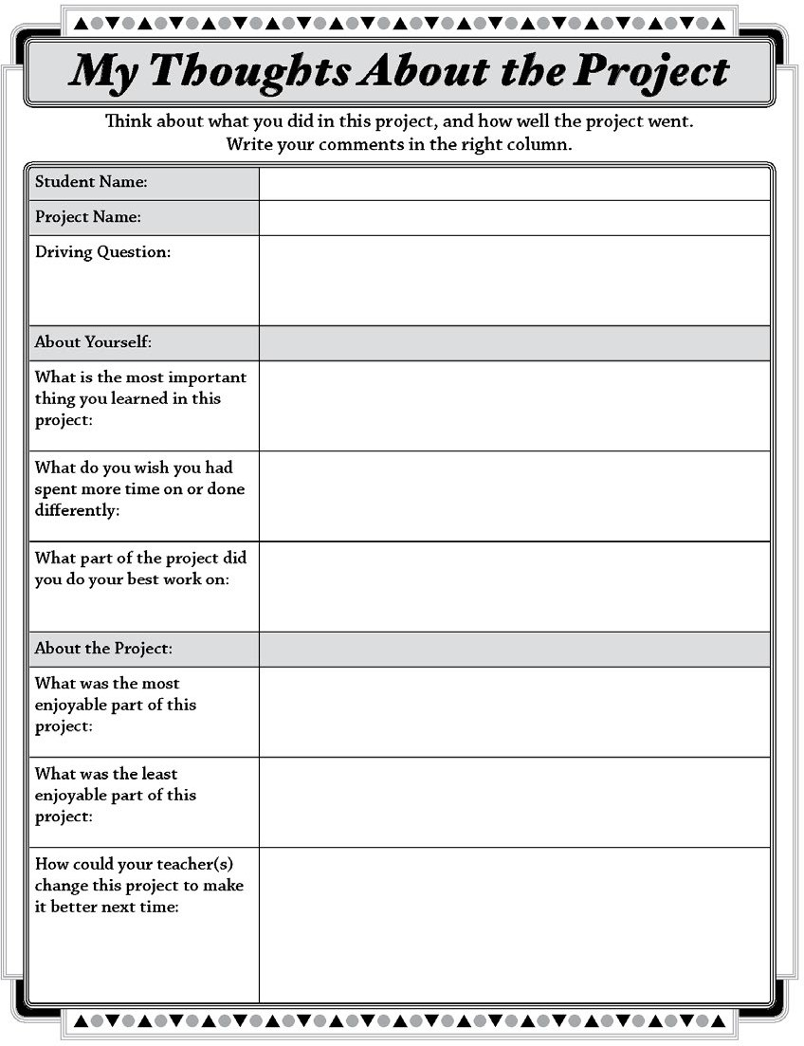

**pblworks.org**

© 2019 Buck Institute for Education